Predict Diagnosis of a Breast Tumor

Objective :
The repository is a learning exercise to:
- Apply the fundamental concepts of machine learning from an available data set
- Evaluate and interpret my results and justify my interpretation based on observed data set
- Create notebooks that serve as computational records and document my thought process.
The analysis is divided into four sections, saved in juypter notebooks in this repository
- Identifying the problem and Data Sources
- Exploratory Data Analysis
- Pre-Processing the Data
- Build model to predict whether breast cell tissue is malignant or Benign

Over View Of Notebooks :
Notebook 1: Identifying the problem and Use external data sources for data enrichment.
Notebook goal: Identify the types of information contained in our data set
In this notebook I used Python modules to import external data sets for the purpose of getting to know/familiarize myself with the data to get a good grasp of the data and think about how to handle the data in different ways.
Notebook 2: Exploratory Data Analysis
Notebook goal: Explore the variables to assess how they relate to the response variable
In this notebook, I am getting familiar with the data using data exploration and visualization techniques using python libraries (Pandas, matplotlib, seaborn. Familiarity with the data is important which will provide useful knowledge for data pre-processing)
Notebook 3: Pre-Processing the data
Notebook goal: Find the most predictive features of the data and filter it so it will enhance the predictive power of the analytics model
In this notebook I use feature selection to reduce high-dimension data, feature extraction and transformation for dimensionality reduction. This is essential in preparing the data before predictive models are developed.
Notebook 4: Predictive model using Support Vector Machine (SVC)
Notebook goal: Construct predictive models to predict the diagnosis of a breast tumor
In this notebook, I construct a predictive model using SVM machine learning algorithm to predict the diagnosis of a breast tumor. The diagnosis of a breast tumor is a binary variable (benign or malignant). I also evaluate the model using confusion matrix the receiver operating curves (ROC), which are essential in assessing and interpreting the fitted model.

Notebook 1

1. Identify the problem
Breast cancer is the most common malignancy among women, accounting for nearly 1 in 3 cancers diagnosed among women in the United States, and it is the second leading cause of cancer death among women. Breast Cancer occurs as a results of abnormal growth of cells in the breast tissue, commonly referred to as a Tumor. A tumor does not mean cancer - tumors can be benign (not cancerous), pre-malignant (pre-cancerous), or malignant (cancerous). Tests such as MRI, mammogram, ultrasound and biopsy are commonly used to diagnose breast cancer performed.

1.1 Expected outcome
Given breast cancer results from breast fine needle aspiration (FNA) test (is a quick and simple procedure to perform, which removes some fluid or cells from a breast lesion or cyst (a lump, sore or swelling) with a fine needle similar to a blood sample needle). Since this build a model that can classify a breast cancer tumor using two training classification:
- 1= Malignant (Cancerous) - Present
- 0= Benign (Not Cancerous) -Absent

1.2 Objective
Since the labels in the data are discrete, the predication falls into two categories, (i.e. Malignant or benign). In machine learning this is a classification problem.
Thus, the goal is to classify whether the breast cancer is benign or malignant and predict the recurrence and non-recurrence of malignant cases after a certain period. To achieve this we have used machine learning classification methods to fit a function that can predict the discrete class of new input.

1.3 Identify data sources
The Breast Cancer datasets is available machine learning repository maintained by the University of California, Irvine. The dataset contains 569 samples of malignant and benign tumor cells.
- The first two columns in the dataset store the unique ID numbers of the samples and the corresponding diagnosis (M=malignant, B=benign), respectively.
- The columns 3-32 contain 30 real-value features that have been computed from digitized images of the cell nuclei, which can be used to build a model to predict whether a tumor is benign or malignant.
DATA TYPES :
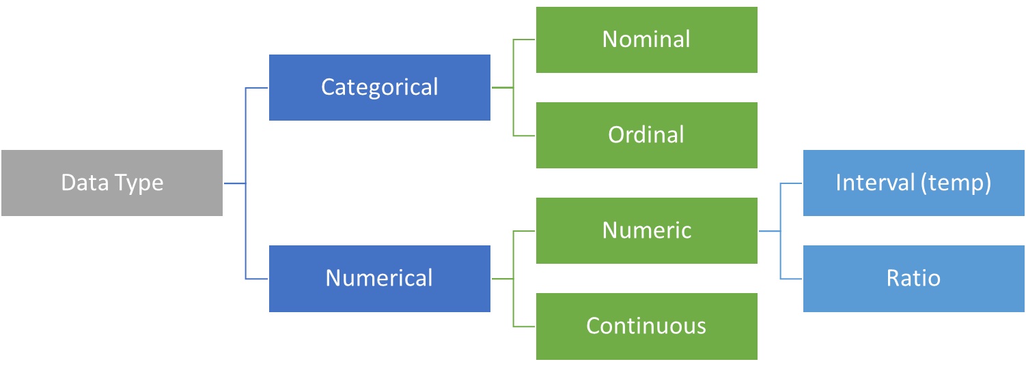

Structured data is data which is a form of data which has a high degree or organization such as numerical or categorical data. Temperature, phone numbers, gender are examples of structured data.
Unstructured data is data in a form which doesn’t explicitly have structure we are used to. Examples of unstructured data are photos, images, audio, language text and many others. There is an emerging field called Deep Learning which is using a specialized set of algorithms which perform well with unstructured data.
The two common types of structured we commonly deal with are categorical variables (which have a finite set of values) or numerical values (which are continuous).
Categorical Variables: Categorical variables can also be nominal or ordinal.
- Nominal data has no intrinsic ordering to the categories. For example gender (Male, Female, Other) has no specific ordering.
- Ordinal data as clear ordering such as three settings on a toaster (high medium and low). A frequency table (count of each category) is the common statistic for describing categorical data of each variable, and a bar chart or a waffle chart (shown below) are two visualizations which can be used.

Numeric Variables: Numeric or continuous variables can be any value within a finite or infinite interval (temperature, height, weight.
There are two types of numeric variables are interval and ratios.
- Interval variables have numeric scales and the same interpretation throughout the scale, but do not have an absolute zero. eg temperature in Fahrenheit or Celcius can meaningfully be subtracted or added (difference between 10 degrees and 20 degrees is the same difference as 40 to 50 degrees) but cannot be multiplied. For example, a day which is twice as hot may not be twice the temperature
- ratio scale of measurement is the most informative scale. It is an interval scale with the additional property that its zero position indicates the absence of the quantity being measured.

Transforming Data: There are a couple of techniques:
- Binning (Numerical to Categorical) -Binning
- Encoding (Categorical to Numerical); Continuization
  - Encoding or continuation is the transformation of categorical variables to binary or numerical counterparts. An example is to treat male or female for gender as 1 or 0. Categorical variables must be encoded in many modeling methods (e.g., linear regression, SVM, neural networks)
  - Two main types of encoding are Binary and Target-based (http://www.saedsayad.com/encoding.htm)
  - Binary encoding is a special case of encoding where the value is set to a 0 or 1 to indicate absence or presence of a category.
  - One hot encoding is a special case where multiple categories are each binary encoded. Given we have k categories, this will create k extra features (thus increasing the dimensionality of the data)

Notebook 2

2.1 Objectives of Data Exploration
Exploratory data analysis (EDA) is a very important step which takes place after feature engineering and acquiring data and it should be done before any modeling. This is because it is very important for a data scientist to be able to understand the nature of the data without making assumptions. The results of data exploration can be extremely useful in grasping the structure of the data, the distribution of the values, and the presence of extreme values and interrelationships within the data set.

The purpose of EDA is:
- to use summary statistics and visualizations to better understand data, *find clues about the tendencies of the data, its quality and to formulate assumptions and the hypothesis of our analysis
- For data preprocessing to be successful, it is essential to have an overall picture of your data Basic statistical descriptions can be used to identify properties of the data and highlight which data values should be treated as noise or outliers.**
Next step is to explore the data. There are two approached used to examine the data using :

- Descriptive statistics is the process of condensing key characteristics of the data set into simple numeric metrics. Some of the common metrics used are mean, standard deviation, and correlation.

- Visualization is the process of projecting the data, or parts of it, into Cartesian space or into abstract images. In the data mining process, data exploration is leveraged in many different steps including preprocessing, modeling, and interpretation of results.

2.2 Unimodal Data Visualizations :

One of the main goals of visualizing the data here is to observe which features are most helpful in predicting malignant or benign cancer. The other is to see general trends that may aid us in model selection and hyper parameter selection.
Apply 3 techniques that you can use to understand each attribute of your dataset independently.
- Histograms.
- Density Plots.
- Box and Whisker Plots.
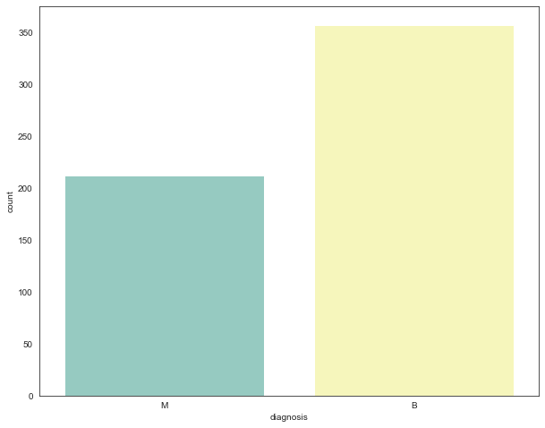
2.3. Visualise distribution of data via histograms :Histograms are commonly used to visualize numerical variables. A histogram is similar to a bar graph after the values of the variable are grouped (binned) into a finite number of intervals (bins).Histograms group data into bins and provide you a count of the number of observations in each bin. From the shape of the bins you can quickly get a feeling for whether an attribute is Gaussian, skewed or even has an exponential distribution. It can also help you see possible outliers.
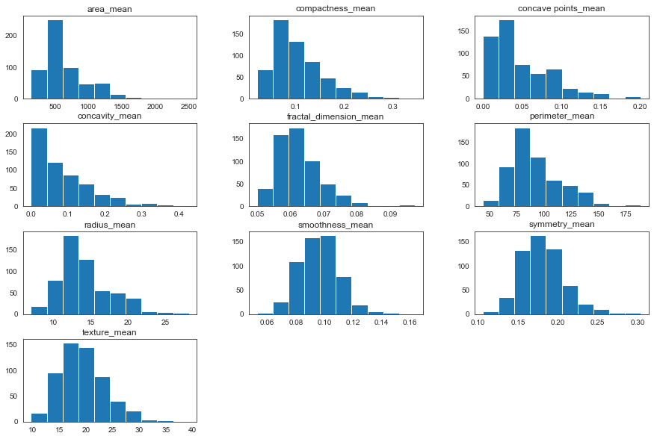

Observation :
We can see that perhaps the attributes concavity,and *concavity_point * may have an exponential distribution ( ). We can also see that perhaps the texture and smooth and symmetry attributes may have a Gaussian or nearly Gaussian distribution. This is interesting because many machine learning techniques assume a Gaussian univariate distribution on the input variables.

2.4 Visualize distribution of data via density plots :

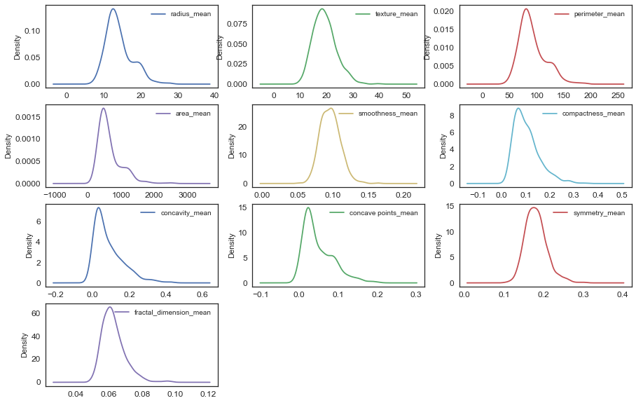

Observation :

We can see that perhaps the attributes perimeter,radius, area, concavity,ompactness may have an exponential distribution ( ). We can also see that perhaps the texture and smooth and symmetry attributes may have a Gaussian or nearly Gaussian distribution. This is interesting because many machine learning techniques assume a Gaussian univariate distribution on the input variables.

2.5 Visualise distribution of data via box plots :
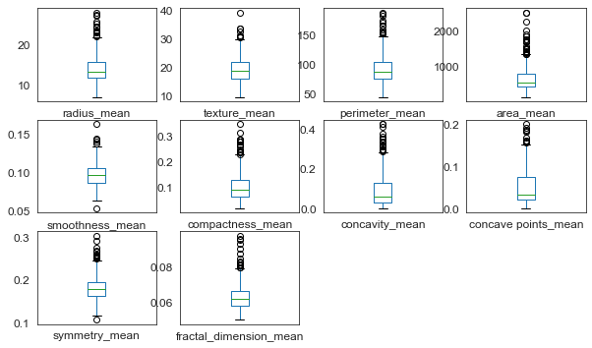

Observation :

We can see that perhaps the attributes perimeter,radius, area, concavity,ompactness may have an exponential distribution ( ). We can also see that perhaps the texture and smooth and symmetry attributes may have a Gaussian or nearly Gaussian distribution. This is interesting because many machine learning techniques assume a Gaussian univariate distribution on the input variables.

Multimodal Data Visualizations :

Correlation matrix :

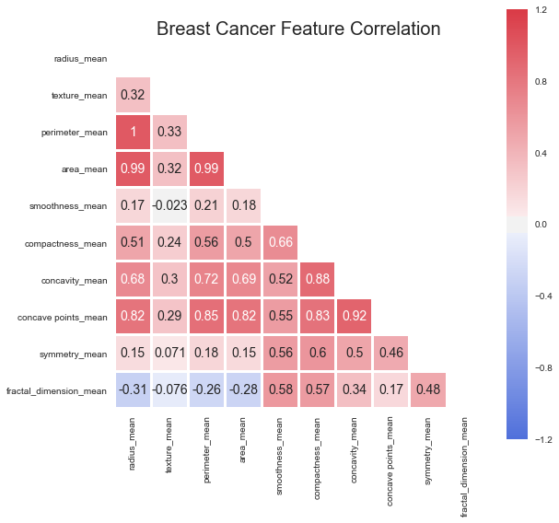

Observation:¶
We can see strong positive relationship exists with mean values paramaters between 1-0.75;.
- The mean area of the tissue nucleus has a strong positive correlation with mean values of radius and parameter;
- Some paramters are moderately positive corrlated (r between 0.5-0.75)are concavity and area, concavity and perimeter etc
- Likewise, we see some strong negative correlation between fractal_dimension with radius, texture, parameter mean values.

Scatter plot :
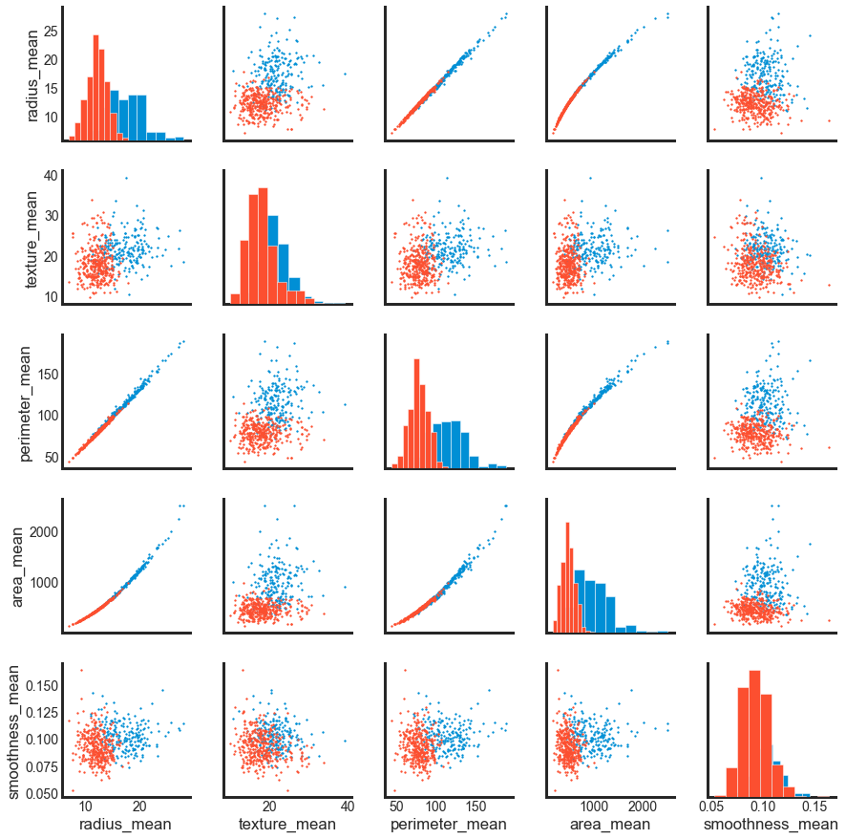

Summary :
1.Mean values of cell radius, perimeter, area, compactness, concavity and concave points can be used in classification of the cancer. Larger values of these parameters tends to show a correlation with malignant tumors.
2.Mean values of texture, smoothness, symmetry or fractual dimension does not show a particular preference of one diagnosis over the other.
3. In any of the histograms there are no noticeable large outliers that warrants further cleanup.

Notebook 3

Introduction :
Data preprocessing is a crucial step for any data analysis problem. It is often a very good idea to prepare your data in such way to best expose the structure of the problem to the machine learning algorithms that you intend to use.This involves a number of activities such as:
- Assigning numerical values to categorical data;
- Handling missing values; and
- Normalizing the features (so that features on small scales do not dominate when fitting a model to the data).
In Notebook-2 NB2_Exploratory data analysis. I explored the data, to help gain insight on the distribution of the data as well as how the attributes correlate to each other. I identified some features of interest. In this notebook I use feature selection to reduce high-dimension data, feature extraction and transformation for dimensionality reduction.

Goal:
Find the most predictive features of the data and filter it so it will enhance the predictive power of the analytics model.

Assesing Model Accuracy: Split data into training and test sets
The simplest method to evaluate the performance of a machine learning algorithm is to use different training and testing datasets. Here I will
- Split the available data into a training set and a testing set. (70% training, 30% test)
- Train the algorithm on the first part,
- make predictions on the second part and
- evaluate the predictions against the expected results.

Feature Standardization :

1.Standardization is a useful technique to transform attributes with a Gaussian distribution and differing means and standard deviations to a standard Gaussian distribution with a mean of 0 and a standard deviation of 1.
2.As seen in NB2_Exploratory data analysis the raw data has differing distributions which may have an impact on the most ML algorithms. Most machine learning and optimization algorithms behave much better if features are on the same scale.

Feature decomposition using Principal Component Analysis( PCA) :

From the pair plot in NB2, lot of feature pairs divide nicely the data to a similar extent, therefore, it makes sense to use one of the dimensionality reduction methods to try to use as many features as possible and maintian as much information as possible when working with only 2 dimensions. I will use PCA

Deciding How Many Principal Components to Retain :
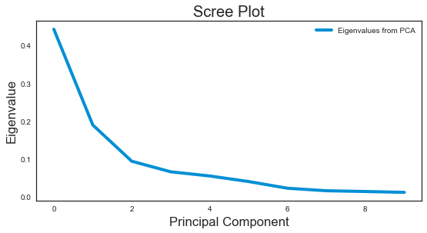

Observation :
The most obvious change in slope in the scree plot occurs at component 2, which is the “elbow” of the scree plot. Therefore, it cound be argued based on the basis of the scree plot that the first three components should be retained.

A Summary of the Data Preprocing Approach used here :

- assign features to a NumPy array X, and transform the class labels from their original string representation (M and B) into integers
- Split data into training and test sets
- Standardize the data.
- Obtain the Eigenvectors and Eigenvalues from the covariance matrix or correlation matrix
- Sort eigenvalues in descending order and choose the kk eigenvectors that correspond to the kk largest eigenvalues where k is the number of dimensions of the new feature subspace (k≤dk≤d).
- Construct the projection matrix W from the selected k eigenvectors.
- Transform the original dataset X via W to obtain a k-dimensional feature subspace Y.
It is common to select a subset of features that have the largest correlation with the class labels. The effect of feature selection must be assessed within a complete modeling pipeline in order to give you an unbiased estimated of your model's true performance. Hence, in the next section you will first be introduced to cross-validation, before applying the PCA-based feature selection strategy in the model building pipeline.

Notebook 4

Predictive model using Support Vector Machine (SVM) :
Support vector machines (SVMs) learning algorithm will be used to build the predictive model. SVMs are one of the most popular classification algorithms, and have an elegant way of transforming nonlinear data so that one can use a linear algorithm to fit a linear model to the data (Cortes and Vapnik 1995)
Kernelized support vector machines are powerful models and perform well on a variety of datasets.
- SVMs allow for complex decision boundaries, even if the data has only a few features.
- They work well on low-dimensional and high-dimensional data (i.e., few and many features), but don’t scale very well with the number of samples.
- SVMs requires careful preprocessing of the data and tuning of the parameters. This is why, these days, most people instead use tree-based models such as random forests or gradient boosting (which require little or no preprocessing) in many applications.
- SVM models are hard to inspect; it can be difficult to understand why a particular prediction was made, and it might be tricky to explain the model to a nonexpert.

Important Parameters
The important parameters in kernel SVMs are the
- Regularization parameter C,
- The choice of the kernel,(linear, radial basis function(RBF) or polynomial)
- Kernel-specific parameters.

Classification with cross-validation :

As discussed in notebook NB3 splitting the data into test and training sets is crucial to avoid overfitting. This allows generalization of real, previously-unseen data. Cross-validation extends this idea further. Instead of having a single train/test split, we specify so-called folds so that the data is divided into similarly-sized folds.

The 5-fold cross-validation accuracy score for this classifier is 0.98
Average score and uncertainty: (94.20 +- 0.496)%

From the above results, you can see that only a fraction of the features are required to build a model that performs similarly to models based on using the entire set of features. Feature selection is an important part of the model-building process that you must always pay particular attention to. The details are beyond the scope of this notebook. In the rest of the analysis, you will continue using the entire set of features.

Model Accuracy: Receiver Operating Characteristic (ROC) curve :
In statistical modeling and machine learning, a commonly-reported performance measure of model accuracy for binary classification problems is Area Under the Curve (AUC).
To understand what information the ROC curve conveys, consider the so-called confusion matrix that essentially is a two-dimensional table where the classifier model is on one axis (vertical), and ground truth is on the other (horizontal) axis, as shown below. Either of these axes can take two values (as depicted)
Model says "+" |Model says "-" --- | --- | --- True positive | False negative | ** Actual: "+" ** False positive | True negative | Actual: "-" In an ROC curve, you plot “True Positive Rate” on the Y-axis and “False Positive Rate” on the X-axis, where the values “true positive”, “false negative”, “false positive”, and “true negative” are events (or their probabilities) as described above. The rates are defined according to the following:

- True positive rate (or sensitivity)}: tpr = tp / (tp + fn)
- False positive rate: fpr = fp / (fp + tn)
- True negative rate (or specificity): tnr = tn / (fp + tn)
In all definitions, the denominator is a row margin in the above confusion matrix. Thus,one can express
- the true positive rate (tpr) as the probability that the model says "+" when the real value is indeed "+" (i.e., a conditional probability). However, this does not tell you how likely you are to be correct when calling "+" (i.e., the probability of a true positive, conditioned on the test result being "+"). 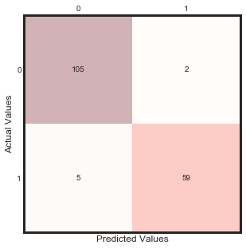
 | precision | recall | f1-score | support
0 | 0.95 | 0.98 | 0.97 | 107
1 | 0.97 | 0.92 | 0.94 | 64
micro avg | 0.96 | 0.96 | 0.96 | 171
macro avg | 0.96 | 0.95 | 0.96 | 171
weighted avg | 0.96 | 0.96 | 0.96 | 171

Observation :
There are two possible predicted classes: "1" and "0". Malignant = 1 (indicates prescence of cancer cells) and Benign = 0 (indicates abscence).
- The classifier made a total of 174 predictions (i.e 174 patients were being tested for the presence breast cancer).
- Out of those 174 cases, the classifier predicted "yes" 58 times, and "no" 113 times.
- In reality, 64 patients in the sample have the disease, and 107 patients do not.

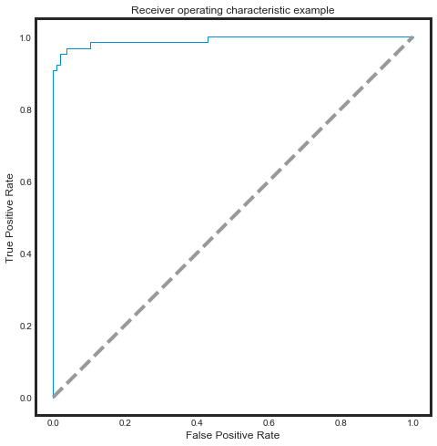

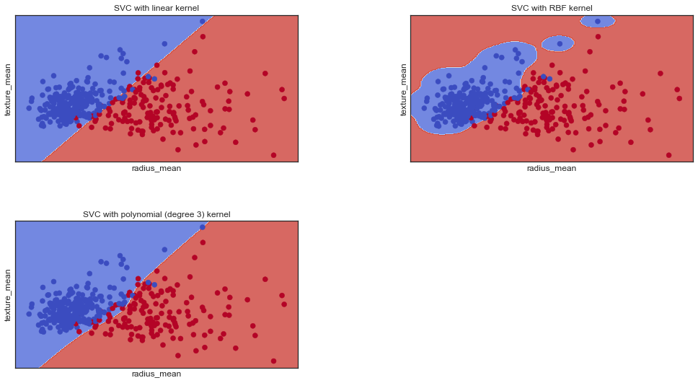

Conclusion :
This work demonstrates the modelling of breast cancer as classification task using Support Vector Machine
The SVM performs better when the dataset is standardized so that all attributes have a mean value of zero and a standard deviation of one. We can calculate this from the entire training dataset and apply the same transform to the input attributes from the validation dataset.

